Chapter 4 Algebra

Algebra is the idea of replacing numbers with letters. Instead of 2 x 3 you have 2x or 2y, for example, meaning “2 times some unknown number.” We've already used variables to replace numbers, and it's a vital tool in programming.

Unfortunately variables are often used to represent a “mystery number” that a student is required to find. Not “find” like Figure 4.1:

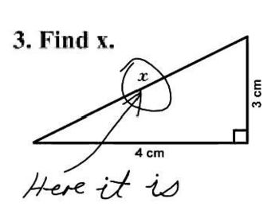
Figure 4.1: Math questions are subject to interpretation.
Every day in Algebra students are given an equation with an unknown (or two or three…) and they have to find what number or numbers make the equation true, like:
1. Solve 2x + 5 = 13.
“Solve” means “find out which number, when you replace x with that number, makes both sides of the equation equal.” Equations of this form don't take too much mental effort to solve, but even at this level we can use Python and “brute force” to plug in random numbers.

Exercise 4.1:
Write a program that will plug all the integers between -100 and 100 into the above equation and if one works, print out the number.

Solution:
def plug():
x = -100
while x < 100:
if 2*x + 5 == 13:
print("x =",x)
x += 1

plug()

The output is

x = 4

This is a valid way to solve a problem! It's too laborious for a human to do by hand, but using a computer it's a cinch. If the solution isn't an integer, you might have to increment by smaller numbers.

All “first-degree” equations, meaning those in which the highest exponent is one, fall into this pattern:

ax + b = cx + d

where a,b,c and d are numbers. Like these ones:

3x - 5 = 22

4x - 12 = 2x - 9

Sometimes there's no x term on one side, so the coefficient is zero. Using a little Algebra, you can solve the general form of the equation and that will help you solve all equations of that form.

ax + b = cx + d

Get all the x's on one side of the equals sign:

ax - cx = d - b
Now factor out an x:

x(a - c) = d - b

Divide both sides by a – c and you have the value of x:

Exercise 4.2:
Write a program that will take the four coefficients of the general equation above and print out the solution.

Solution:

def equation(a,b,c,d):
'''solves equations of the
form ax + b = cx + d'''
return (d - b)/(a - c)

Let's test it with an equation we've solved already:

>>> equation(2,5,0,13)
4.0

Now for a more complicated one:
12x + 18 = -34x + 67

>>> equation(12,18,-34,67)
1.065217391304348

How do we check it? We plug that solution in for x. But why type all those digits? Notice we didn't use “print” in the program, but we used “return” instead. This means we can assign the result to a variable:

>>> x = equation(12,18,-34,67)
>>> x
1.065217391304348

Now find out what the left side of the equation becomes with that number for x:

>>> 12*x + 18
30.782608695652176

Is it the same as the right side of the equation?

>>> -34*x + 67
30.782608695652172

Except for some rounding error at the end, yes!

Higher Degree Equations

If you're faced with an equation with a squared term in it, like ax² + bx + c = 0, you should use the Quadratic Formula:

Exercise 4.3:
Write a program that will take a, b and c above and return the two solutions to the quadratic formula. Use it to solve x² + 3x – 10 = 0.

Solution:

add this line to the top of your Python file to import the square root function:

from math import sqrt

Here's the function:

def quad(a,b,c):
'''Returns the solutions of an equation
of the form a*x**2 + b*x + c = 0'''
x1 = (-b + sqrt(b**2 - 4*a*c))/(2*a)
x2 = (-b - sqrt(b**2 - 4*a*c))/(2*a)
return x1,x2

>>> quad(1,3,-10)
(2.0, -5.0)

Here's how we check the answers:

>>> 2**2 + 3*2 - 10
0
>>> (-5)**2 + 3*(-5) - 10
0

Factoring

Many problems require students to solve those quadratic equations (with an x² term) by factoring. Factoring means reducing one number into the product of two or more numbers, like 30 = (5)(6). That means ax² + bx + c (if it's factorable) can be split into the form

(dx + e)(fx + g)

d and f are factors of a, and e and g are factors of c. All you have to do is go through all the factors of a and all the factors of c, and see if d*g + e*f equals b. It would be annoying for a human to go through every possible combination, but computers were made for such repetition. Remember the program you wrote that factored an integer? We need to adapt it to include the negative factors, too.

Exercise 4.4:
Write a program that will factor an integer and put all its factors (including negative ones!) into a list, like this:

>>> factor(6)
[1, -1, 2, -2, 3, -3, 6, -6]

Solution:
def factor(num):
factors = [] #factor list
num = abs(num) #use the absolute value
for i in range(1,num+1):
if num % i == 0:
factors.append(i)
factors.append(-i)
return factors

Now all you have to do is go through all the factors, add up d*g + e*f and see which combination adds up to b.

Exercise 4.5:
Write a program that will take a, b and c and print out the factored form of the polynomial, if it is factorable.

Solution:
def factorPoly(a,b,c):
afactors = factor(a) #get the factors of a
cfactors = factor(c) #get the factors of c
for afactor in afactors: #try all the factors of a
for cfactor in cfactors: #and c
#see which combination adds up to b
if afactor * c/cfactor + a/afactor * cfactor == b:
print("(",afactor,"x +",cfactor,")(",
int(a/afactor),"x +",int(c/cfactor),")")
return

>>> factorPoly(6,-1,-15)
( 2 x + 3 )( 3 x + -5 )

Unfortunately, not all polynomials are factorable. But using the Quadratic Formula will always work, even if the solutions aren't integers, rational numbers or even real numbers!

Solving Higher Degree Equations

In Algebra class students are often asked to solve a higher degree equation, like

6x³ + 31x² + 3x – 10 = 0

You can use the “plug” function and look for solutions manually:

def g(x):
return 6*x**3 + 31*x**2 + 3*x – 10

def plug():
x = -100
while x < 100:
if g(x) == 0:
print("x =",x)
x += 1
print("done.")

>>> plug()
x = -5
done.

That gives you one of the solutions. What if there were a way to see all the possible inputs and their corresponding outputs to a function? Well, there is, and it's called graphing.

Creating Your Own Graphing Tool
We're going to use Processing to create a graphing tool that will allow us to see how many solutions our equation has. The basic setup of a Processing sketch in Python mode is shown in Figure 4.1:

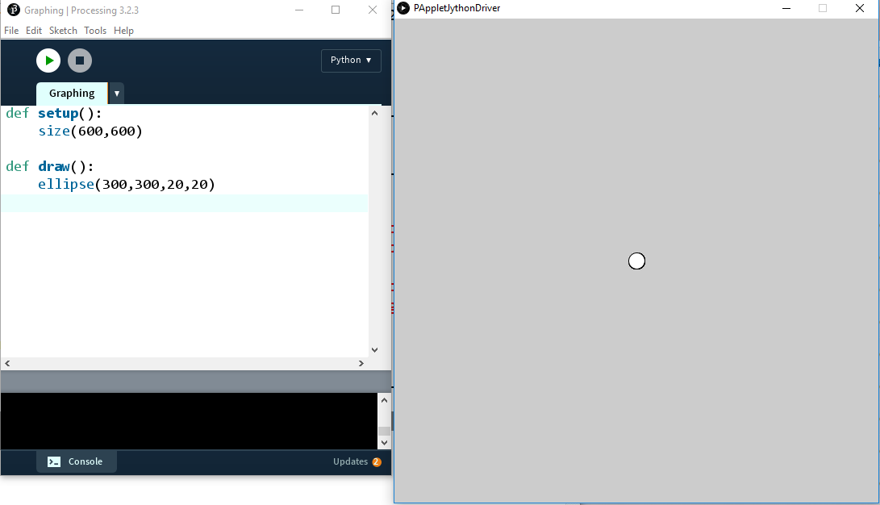
Unfortunately for us, computer graphics usually have their “origin” in the top left corner of the screen and the y-coordinates get larger as they go down the screen, not up, like in Figure 4.2:

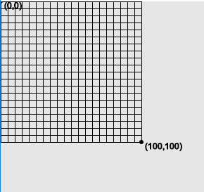

To move the origin to the center of the screen, we use the “translate” function:

translate(width/2, height/2)
So the origin will be in the middle of the screen. You won't see what's in Figure 4.3, but you get the idea:
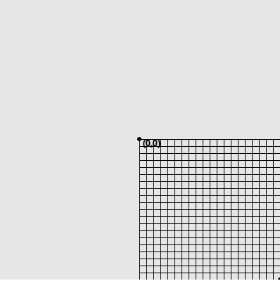
Our screen is still 600 pixels by 600 pixels but we probably will only need x- and y- values from -10 to 10. We can use Processing's scale function to scale it down:

scale(width/20)

Now we'll draw lines for the grid, in blue, like graph paper. The lines will go (x, -10) to (x, 10) for each x value and from (-10, y) to (10, y) for each y-value. That should give us a nice grid, but unfortunately it gives us Figure 4.4:
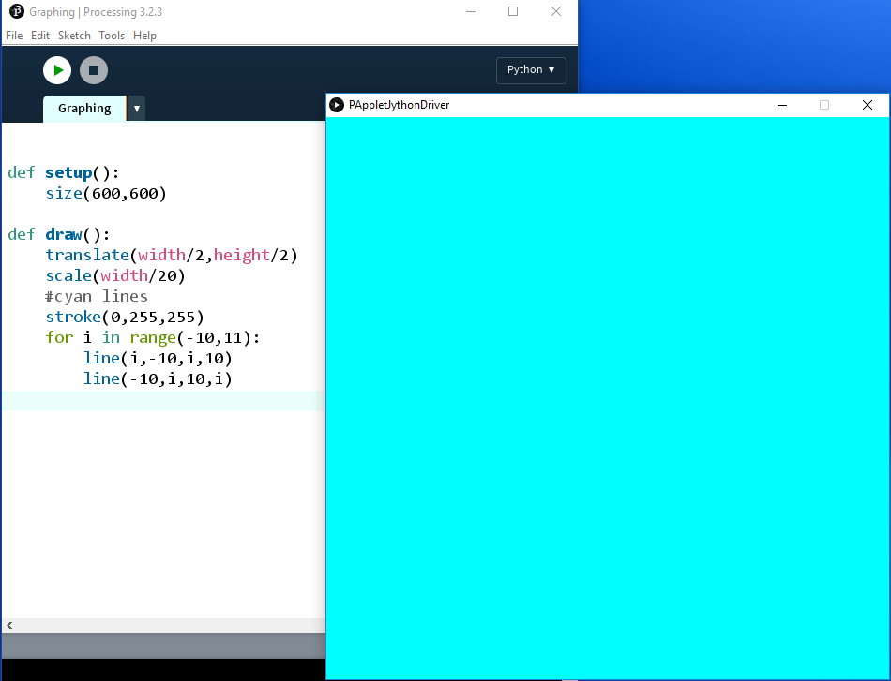
Because of the scaling, the lines look very thick. So thick, in fact, they look like a sky blue field. All we need to do is to reduce the strokeWeight in the setup function:
strokeWeight(1/2)
Add “background(255)” to the beginning of the draw function to set the background white and you'll have a nice blue grid, as in Figure 4.5:

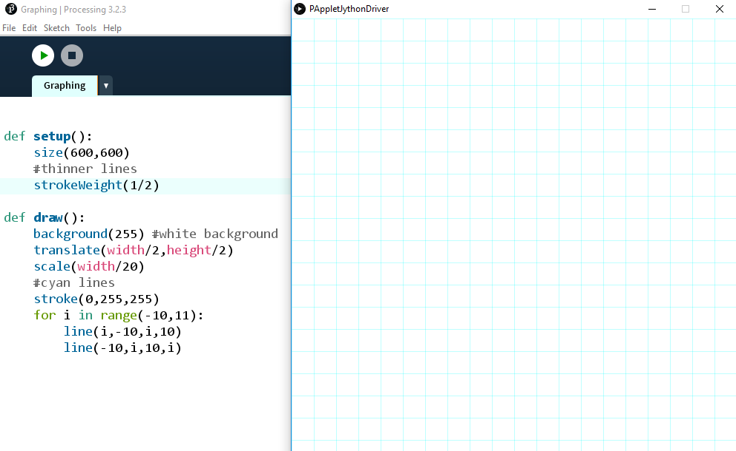
Now adding the axes should be a cinch.
Exercise
Draw two black lines for the x- and y-axes.
Solution:
After drawing the blue lines, add the following code:
stroke(0) #black axes
line(0,-10,0,10)
line(-10,0,10,0)

That will make your graph look like Figure 4.6:


This looks done, but if we try to put a point (an ellipse, actually) at (3,6), we see a problem:

fill(0)
ellipse(3,6,1,1)

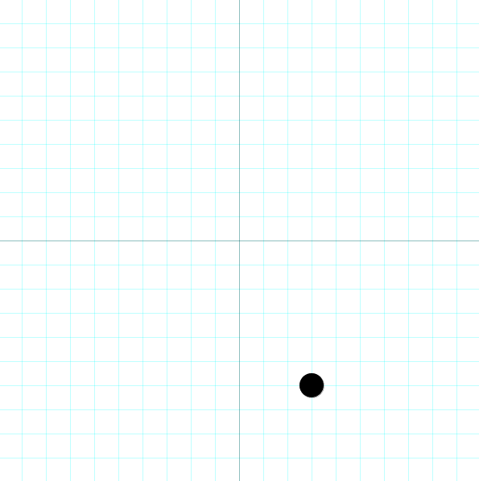
The y-coordinates go up as we go down the screen, so our graph is “upside-down.” We can add one final line to our draw function to flip that over:
scale(1,-1)

This scales the x- and y- coordinates. Since the numbers are ones it doesn't change the size of the output, but the y-value is negative so it flips the output to how we want it, like in Figure 4.7:

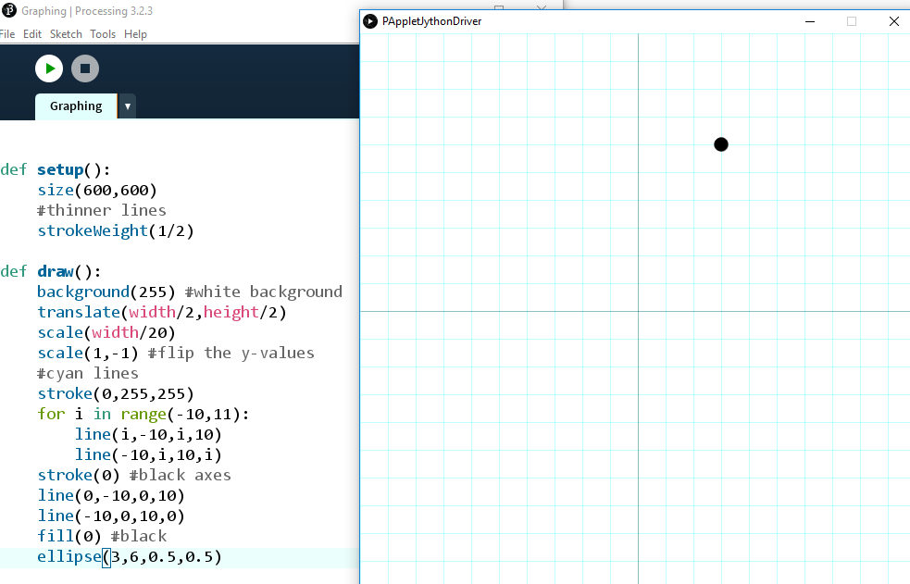

Now we're ready to solve our equation:

6x³ + 31x² + 3x – 10 = 0

We'll add the function

def f(x):
return 6*x**3 + 31*x**2 + 3*x – 10

to our program and draw lines from every point to every “next” point, going up a tenth of a unit at a time:

def graphFunction():
x = -10
while x <= 10:
line(x,f(x),x+0.1,f(x+0.1))
x += 0.1

Finally, call “graphFunction” in draw function and you'll see the output in Figure 4.8:

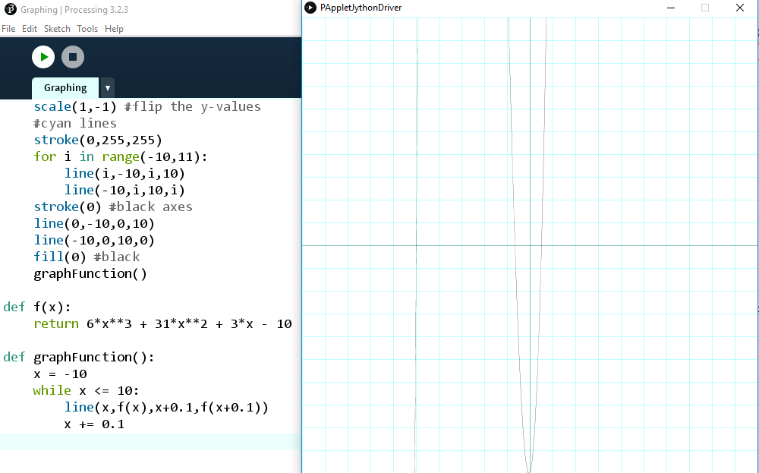
The solutions to the equation are where the graph crosses the x-axis. We can see three places: where x = -5, where x is between -1 and 0, and where x is between 0 and 1.
The Halving Method
The easiest way to approximate the roots is by halving the range. Let's start with the root between 0 and 1. Is it 0.5? We can easily plug in 0.5 and see. We'll move to IDLE for this:

def f(x):
return 6*x**3 + 31*x**2 + 3*x – 10

>>> f(0.5)
0.0

Another solution to our equation is 0.5. Finally, we'll try the root between -1 and 0.

>>> f(-0.5)
-4.5

Looking at the graph, now we can tell the root is somewhere between -1 and -0.5. We'll average those endpoints and try again:

>>> f(-0.75)
2.65625

That's positive, so the solution is between -0.75 and -0.5:
>>> f(-0.625)
-1.23046875

Too high. Do you see how we might use Python to do these steps for us?

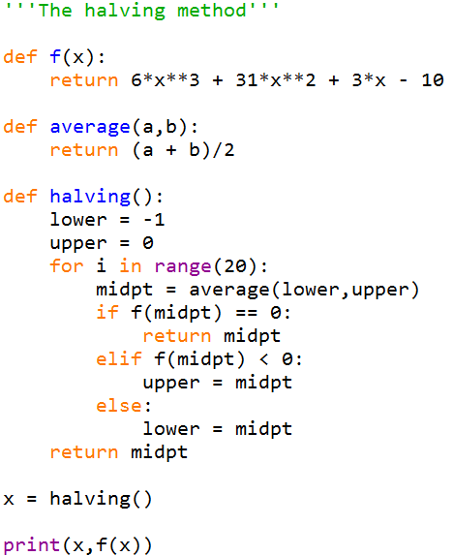
The output is
-0.6666669845581055 9.642708896251406e-06
x looks like it's around -2/3 and f(x) is close to 0. The “e-06” at the end means scientific notation. In decimal terms, that number is 0.00000964. If we increase the number of iterations from 20 to 40, we'll get a number even closer to 0:
-0.6666666666669698 9.196199357575097e-12
Let's check f(-2/3):
>>> f(-2/3)
0.0

The three solutions to the equation

6x³ + 31x² + 3x – 10 = 0

are x = -5, -2/3 and ½.
So now all we have to do to solve an equation, no matter how complicated, is graph it and approximate where it crosses the x-axis. By iterating and “halving” the range of values that work, we can get as accurate as we want.
When we learn a Calculus trick called the derivative, we'll have another method to solve equations like this. And when we really learn to use matrices, we'll learn how to solve systems of equations, like these:

a + 2b -4c + d = -9
2a – 3b + 2c – 5d = 21
5a + b + 8c + 6d = -1
12a – 7b + 6c – 2d = -8

Variables are Supposed to Vary
People familiar with x's and y's in Algebra class might think variables represent a specific (and secret) number that people have to figure out. But that's not how variables are used in the real world. As you might suspect from their name, “variables” are letters that represent numbers that will vary, or change. We've already seen “i” used in this way in loops:
>>> for i in range(5):
print(i)
0
1
2
3
4

The variable i starts off as 0 and changes (or “varies”) every loop. This is incredibly useful, since it allows us to easily deal with situations when numbers change. We also saw how easy variables make things when a number pops up repeatedly, and changing a number once is easier than changing it throughout the code. A simple example is the polygon function:
def polygon(num):
for i in range(num):
fd(100)
rt(360/num)
Whenever you want to change the number of sides in the polygon, the variable called “num” changes the value automatically throughout the function.

